GOVERNMENT ENGINEERING COLLEGE, BHARUCH

Student's Weekly Report of Internship
Student Name: | PATEL BINIT UMESHKUMAR
Enrollment Number: | 230143107014
Week Duration: | January 15, 2026 - January 21, 2026 (Week 3)
Name Of Organization: | Microsoft Elevate Program (via Edunet Foundation & FICE Education)
External Guide Name: | Adarsh Gupta
External Guide Contact: | 0124-4080107

Work done in last Week with description:

1. Week 3 Module: DAX (Data Analysis Expressions) in Power BI

Description:
Attended live session on "DAX (Data Analysis Expressions)" on February 6, 2026. Learned about DAX fundamentals, creating calculated columns and measures, and using DAX functions for data analysis in Power BI.

Key Topics Covered:
- Introduction to DAX syntax and structure
- Calculated columns vs Measures - differences and use cases
- Basic DAX functions: SUM, AVERAGE, COUNT, MIN, MAX
- CALCULATE function for context manipulation
- Filter context and row context concepts
- Time intelligence functions (DATESYTD, TOTALYTD)

Practical Exercise:
Created simple DAX measures for a sample sales dataset including Total Sales, Average Sales, and Year-to-Date calculations. Practiced writing DAX formulas in Power BI Desktop.
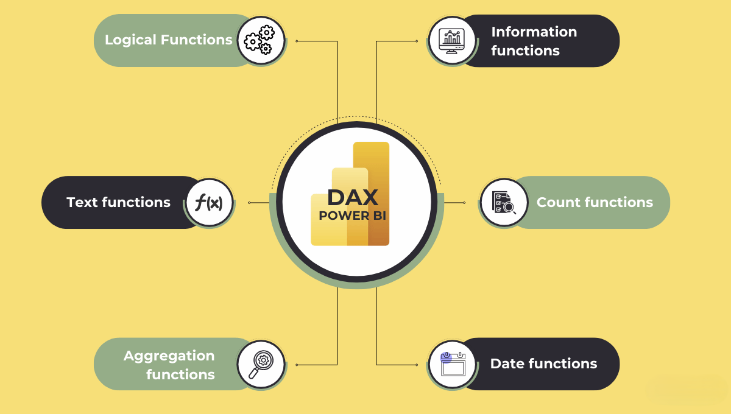
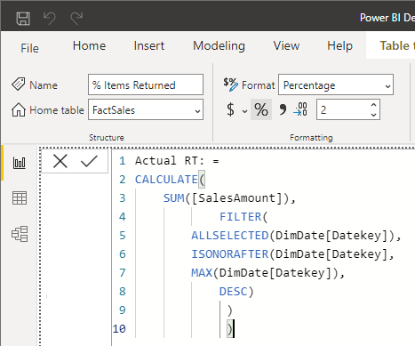

2. Week 3 Module: Power BI Visualizations

Description:
Attended session on "Visualizations in Power BI" on February 9, 2026. Learned about different types of visualizations, best practices for choosing appropriate charts, and customizing visuals for effective data storytelling.

Key Topics Covered:
- Types of visualizations: Bar, Column, Line, Pie, Scatter, Map, Table, Matrix
- Choosing the right visualization for different data types
- Formatting visuals: colors, labels, titles, legends
- Custom visuals from AppSource marketplace
- Card visuals and KPI indicators
- Conditional formatting in tables and matrices

Hands-on Practice:
Created multiple visualizations using sample data: sales trends with line charts, regional performance with map visualization, and product category analysis with bar charts. Applied formatting and color themes for professional appearance.
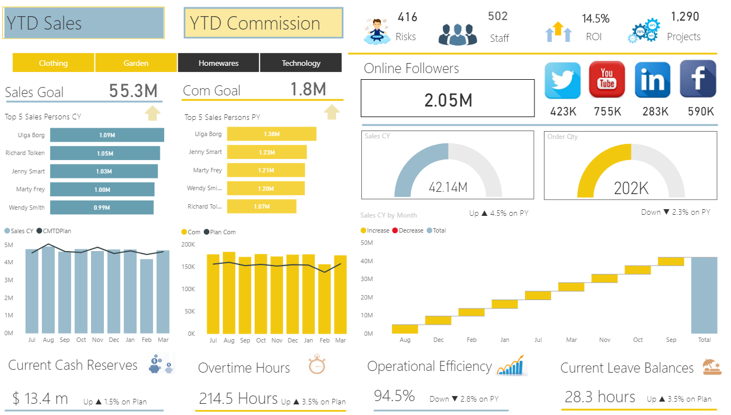

3. Week 3 Module: Interactivity in Power BI

Description:
Participated in "Interactivity" session on February 11, 2026. Learned about adding interactive features to Power BI dashboards including slicers, filters, drill-through, and cross-filtering capabilities.

Key Topics Covered:
- Slicers and their types (list, dropdown, date range)
- Visual-level, page-level, and report-level filters
- Cross-filtering and cross-highlighting between visuals
- Drill-down and drill-through functionality
- Bookmarks for creating navigation and storytelling
- Buttons and actions for user interaction

Practical Implementation:
Built an interactive dashboard with slicers for date range and product categories. Implemented drill-through functionality to show detailed information when clicking on summary data. Configured cross-filtering between multiple charts for enhanced user experience.
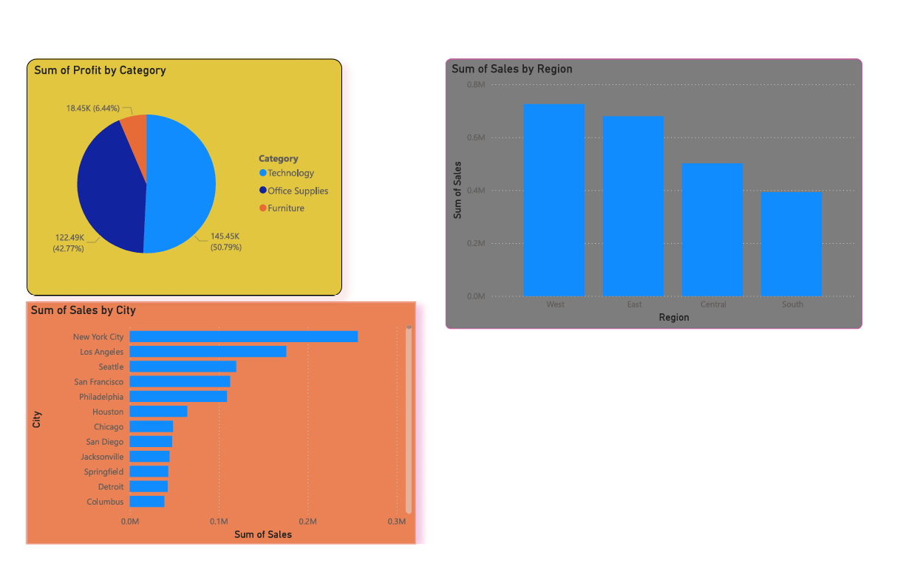

4. Dataset Acquisition and Initial Exploration

Description:
Started dataset acquisition for the Border Surveillance project. Downloaded sample surveillance videos and explored dataset characteristics.

Work Completed:
- Downloaded 15 sample videos from UCF-Crime dataset subset (normal and anomaly categories)
- Created organized folder structure: Data/raw/ucf_crime/, Data/processed/
- Analyzed video properties: resolution (320x240 to 640x480), duration (30s to 2min), format (AVI/MP4)
- Created dataset documentation file listing video names, categories, and characteristics
- Noted storage requirements: approximately 500MB for 15 videos

5. OpenCV Learning and Video Processing Practice

Description:
Completed OpenCV tutorials focusing on video processing capabilities. Practiced frame extraction and basic image operations needed for the surveillance project.

Skills Learned:
- Installing OpenCV: pip install opencv-python opencv-contrib-python
- Reading video files using cv2.VideoCapture()
- Extracting frames from videos (1 frame per second)
- Resizing frames to standard dimensions (640x640)
- Converting color spaces (BGR to RGB)
- Saving processed frames as image files

Practice Code:
Wrote Python script to extract frames from one sample video. Successfully extracted 60 frames from a 1-minute video clip. Tested frame quality and verified that extracted frames are suitable for further processing.
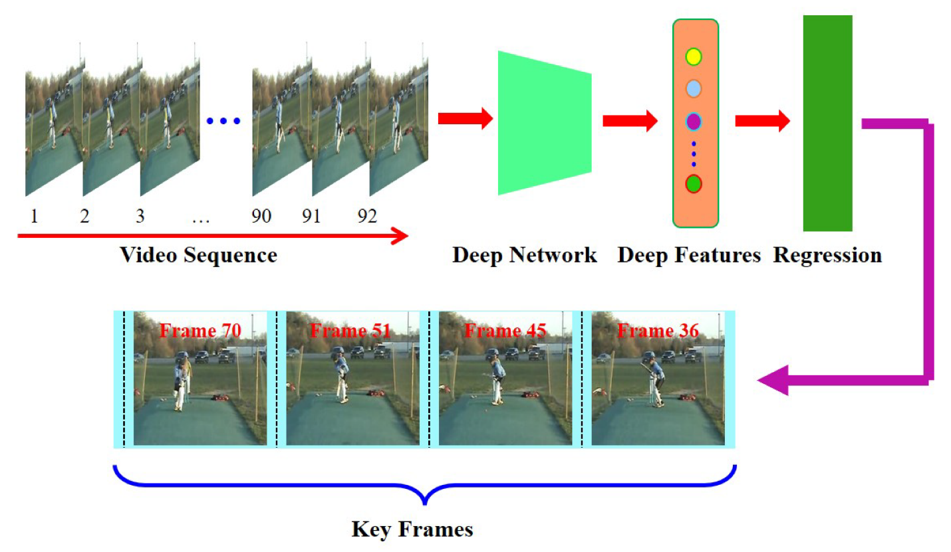

6. Azure for Students Account Registration

Description:
Successfully registered for Azure for Students account and explored the Azure portal interface and available services.

Setup Completed:
- Registered with SAL Institute email for Azure for Students
- Verified student status and received ₹15,600 (approx $200) in free credits
- Explored Azure portal dashboard and navigation
- Reviewed available services: Blob Storage, Functions, Cosmos DB, Computer Vision
- Read Azure documentation on Blob Storage for video/image storage
- Learned about Azure Functions for serverless computing

Next Steps Identified:
Will create storage account for project data in Week 4. Plan to setup Azure Blob containers for storing surveillance videos and processed frames. Will explore Azure Functions for running detection models.
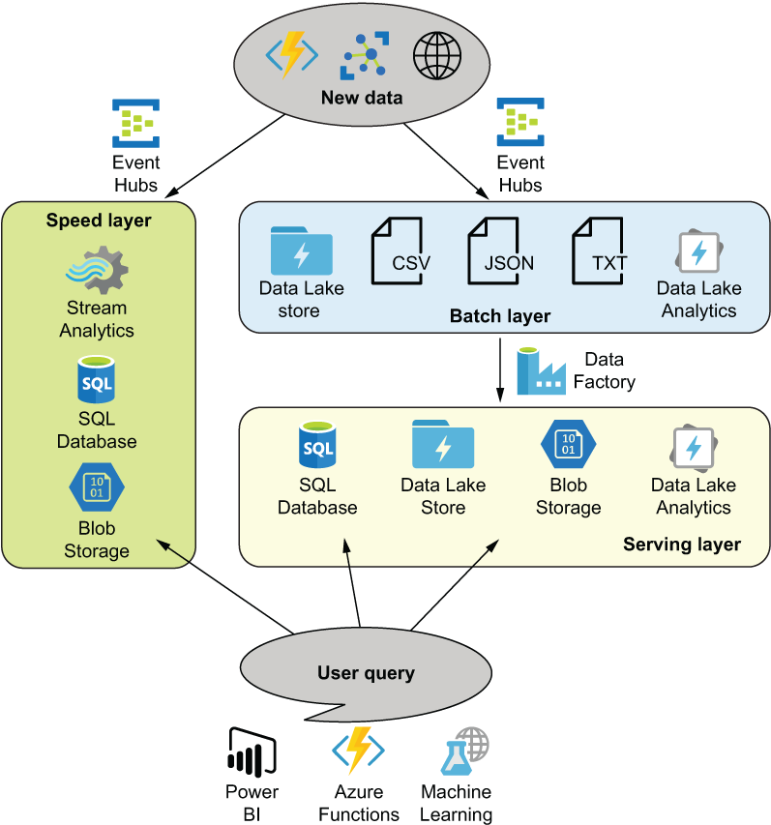

Plans for next week (Feb 17-21, 2026):

1. Complete Week 4 Microsoft Elevate Modules
- Attend "Advanced DAX" session (Feb 13)
- Participate in "Power BI Dashboard" session (Feb 16)
- Learn about "Machine Learning" introduction (Feb 18)
- Complete hands-on Power BI dashboard assignment

2. Process Downloaded Datasets
- Extract frames from all 15 downloaded videos using OpenCV
- Create metadata CSV file with frame information
- Organize frames into normal/anomaly categories
- Perform basic EDA on extracted frames (count, size, quality)

3. Azure Storage Setup
- Create Azure Storage Account
- Setup Blob containers (videos, frames, models)
- Test uploading sample video and frames to Azure
- Learn Azure Storage Python SDK basics

4. GitHub Repository Setup
- Create GitHub repository: "Border-Surveillance-AI"
- Initialize with README.md, .gitignore, and LICENSE
- Create folder structure: data/, notebooks/, src/, models/, docs/
- Upload OpenCV frame extraction script
- Write comprehensive README with project overview

5. Begin YOLOv8 Research
- Research YOLOv8 architecture and capabilities
- Install Ultralytics YOLOv8 library
- Test pre-trained YOLOv8 model on sample images
- Understand training requirements and dataset format

Total Working Hours: 32 hours
Signature of Student: _____________________
The above entries are correct, and the grading of work done by Trainee is:
Excellent | Very Good | Good | Fair | Below Average | Poor
☐ | ☐ | ☐ | ☐ | ☐ | ☐

Signature of External Guide with Company Seal: _____________________
Date: ___________
Signature of Internal Guide: _____________________
Date: ___________

